THE NEUTRINO MYSTERY  
- Harpreet Singh Khalsa, BVCOE  
  
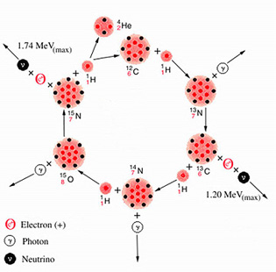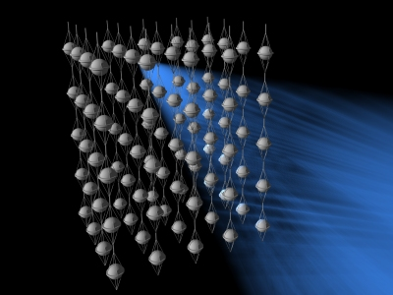

Hey, look! Here pass millions of neutrinos from your book. Oh my God, now they have crossed the moon!

You must be thinking, “What is it? I couldn’t see anything”. Well, relax. You are right. If you could actually see them, you wouldn’t have required a bulb to study at night. The small size and huge quantity of neutrinos furnish them with a tendency to behave similar to photons, thus imparting the potential to illuminate a night as a day. They are particles so light that even a 100,000 neutrinos may not balance one electron, but considering their titanic abundance in the universe, they may overtake the mass of matter present on our planet.

Unfortunately, even half a century after their discovery, there’s little that we know about them.  
  
While studying the emissions produced in certain radioactive transitions, the existence of tiny neutral particles was first predicted by physicist Wolfgang Pauli. He asserted on the basis of certain observations and experiments that the virtually massless particles would rarely interact with matter.

Arising out of fusion, Solar Neutrinos engender as a result of the nuclear reactions taking place in the core of the Sun and other stars. In due course of time, the ongoing research and experiments have indicated that even animals and humans produce another class of neutrinos as a byproduct of decomposition of their skeletal system.

The low mass and neutral charge of a neutrino impart it an exceedingly weak interaction with other particles and fields. Such attributes interest scientists because they indicate that neutrinos can be used to probe environments that other radiations (such as light or radio waves) cannot penetrate, thereby making it a particle of paramount importance to disentangle many mysteries. Alas, catching their holy grail is nothing less than catching a ghost!

